About Capstone Project Crime In India

**Introduction**

1. **Background Information**

Crime is an act that violates the law and is punishable by the state. It encompasses a wide range of activities, including violent acts like murder and assault, property crimes such as theft and burglary, and non-violent offenses like fraud and cybercrime. Crimes disrupt social order and harm individuals or communities, prompting legal systems to impose penalties to deter and address such behavior. Understanding crime involves examining its causes, types, and societal impact, which is crucial for developing effective prevention and intervention strategies.

**2. Problem Statement**

The primary goal of this project is to analyze crime data across various states and union territories (UTs) in India, examine the relationship between different socio-economic factors and crime rates, and use machine learning techniques to categorize districts into clusters based on their crime profiles. The project is divided into four phases: data collection and preparation, state/UT-wise analysis, SQL operations, and unsupervised machine learning for clustering.

**Phase 1: Data Collection and Preparation**

**Phase 2: State/UT-Wise Analysis**

Analysis Components:

1. Literacy Rate vs. Total Crimes:

2. Type of Crime vs. Literacy Rate:

3. Year-on-Year Total Crime Rate:

4. Area vs. Overall Crime:

5. Population vs. Overall Crime:

6. State Crime Reports:

**Phase 3: SQL Operations**

Task: Manage and analyse crime data using SQL, focusing on specific queries to extract valuable insights.

Steps:

1. Create Tables:
   * Define and create tables for different datasets.
2. Insert Records:
   * Populate the tables with records from various CSV files.
3. Execute SQL Queries:
   * Perform specific queries to identify trends and insights, such as finding the highest and lowest numbers of certain crimes, identifying districts with specific crime patterns, and more.

**Phase 4: Unsupervised Machine Learning (Clustering)**

Task: Cluster districts into categories based on crime data and analyze these clusters to provide actionable insights for higher authorities.

Steps:

1. Data Preparation:
   * Merge relevant datasets and select appropriate columns for clustering.
2. Clustering:
   * Use clustering algorithms to categorize districts into three clusters: Sensitive Areas, Moderate Areas, and Peaceful Areas.
3. Cluster Analysis:
   * Create DataFrames for each cluster and conduct detailed analyses.
4. Reporting:
   * Prepare a comprehensive report with observations and recommendations, including factors impacting crime, measures to reduce crime, and identification of the most and least safe districts.

This project entails a structured approach to analyzing crime data across Indian states and UTs, utilizing statistical analysis, SQL operations, and machine learning clustering techniques. The outcome will provide valuable insights into crime patterns and recommendations for improving safety and security across different regions.

**3. Methodology Overview**

For this project, we began with extensive market research to gain a deep understanding of crime and its influencing factors. Our focus was specifically on the Indian crime dataset. We meticulously analyzed the dataset features to determine how to enhance and modify the data without compromising the goal. This process involved cleaning the data, removing unnecessary values, and creating new attributes through data integration methods.

Subsequently, we conducted Exploratory Data Analysis (EDA) and Data Visualization to uncover patterns and insights. This phase helped us identify trends and correlations within the data, providing a solid foundation for further analysis.

**Tools and Libraries Used**

**1. Jupyter Notebook:**

* Used for writing and running code in an interactive environment.

**2. Python Libraries:**

* **Pandas:** Data manipulation and analysis.
* **NumPy:** Numerical computing.
* **Seaborn and Matplotlib:** Data visualization.
* **Warnings:** Managing warning messages.

**3. SQL -Workbench**

**4. Unsupervised Learning**

We employed the K-means clustering algorithm for unsupervised learning. This model helped us categorize the districts into three clusters: Sensitive Areas, Moderate Areas, and Peaceful Areas. By analyzing these clusters, we were able to provide actionable insights and recommendations for crime prevention and safety improvements.

**Project Description**

1. **Data Collection**

The first important step is to collect data. After formulating the business problem, it is important to understand the data sources. The dataset used in this project is dataset link provided by Data Trian Education and is available on GitHub and remaining data I have download from google and Kaggle .

**Crime related data**

Link:- <https://www.kaggle.com/datasets/rajanand/crime-in-india>.

**Literacy rate** .

Link:- <https://www.indiabudget.gov.in/economicsurvey/doc/stat/tab85.xlsx>

**Population Data**

Link:- <https://www.prb.org/resources/table-population-of-states-and-union-territories-uts-of-india-2001-and-2011-and-rates-of-change-in-the-past-three-censuses/>

1. **Dataset Overview**

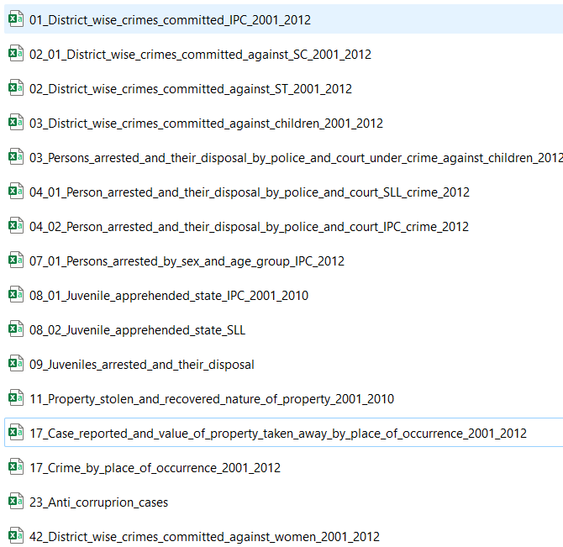 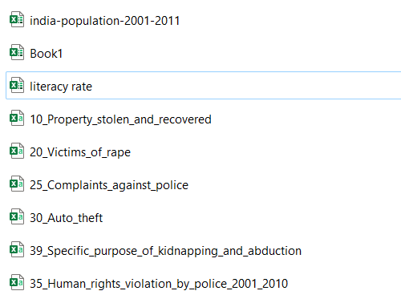

1. **Data Pre-Processing**

Pre-processing is a critical step in machine learning that can significantly enhance the quality of information, thereby facilitating the extraction of meaningful insights. It involves preparing (cleaning and organizing) raw data to make it suitable for building and training machine learning models. In essence, data preprocessing is an information mining technique that transforms raw data into a comprehensible and structured format. Once raw data is collected, it must be organized to be ready for further processing and analysis.

1. **Data Cleaning and Exploratory Data Analysis**

Data cleaning is an essential step in preparing data for analysis. It ensures that the dataset is free from errors that could affect the results. Common issues like duplicate records, missing values, or inconsistent data need to be fixed. In this step, we remove bad data and fill in any missing information. The aim is to tidy up the dataset by getting rid of unnecessary information and adding any missing pieces, ensuring that the data is accurate and ready for analysis.

1. **Visualization and Insights Overview**

Visualization is crucial in data analysis because it simplifies complex data, enhances understanding, and facilitates easy comparisons. It improves communication by making data insights accessible to all stakeholders, supporting better decision-making. Additionally, visualization can reveal hidden patterns and engage the audience effectively.

1. Univariate Analysis: This involves examining each variable individually to understand its distribution, central tendency, and variability.
2. Bivariate Analysis: This examines the relationship between two variables.
3. Multivariate Analysis: This involves exploring the relationships between three or more variables simultaneously.

Insights from phase 2 analysis

* Top Performers: Kerala (90.86%) has the highest literacy rate, followed by Mizoram (88.8%) and Lakshadweep (86.66%).
* Low Performers: Bihar (47%) has the lowest literacy rate, significantly below other states/UTs.
* Mid-Range Performers: States like Maharashtra (76.88%) and Tamil Nadu (73.45%) are in the mid to high range.
* Clustered Ranges: Most states/UTs have literacy rates clustered between 60% to 80%.

From the IPC crime data of 2001 to 2011, we can observe several key points:

* Highest Literacy Rate: Kerala has the highest literacy rate at 90.86%, followed by Lakshadweep (88.8%) and Mizoram (86.66%).
* Lowest Literacy Rate: Bihar has the lowest literacy rate at 47%.
* General Observation on Literacy: Literacy rates vary significantly across states and UTs. Many states achieve literacy rates above 75%, indicating a general trend towards higher literacy, although there are exceptions like Bihar with much lower rates.

From the Sc crime 2001-2011 we can observe serval key points

* States with literacy rates around 72.9% to 74.4% show very high crime rates.
* States with higher literacy rates, around 91.8% to 94.0%, exhibit much lower crime rates.
* Uttar Pradesh, with the highest crime rate of 8378.25, has a literacy rate of 67.2%.
* Arunachal Pradesh, with the lowest crime rate of 2006.67, has a literacy rate of 61.8%.

From the ST crime 2001-2011 we can observed serval key points

* States with literacy rates around 72.9% to 74.4% show very high crime rates.
* States with higher literacy rates, around 91.8% to 94.0%, exhibit much lower crime rates.
* Uttar Pradesh, with the highest crime rate of 8378.25, has a literacy rate of 67.2%.
* Arunachal Pradesh, with the lowest crime rate of 2006.67, has a literacy rate of 61.8%.

**Overview of Crime Trends in India (2001-2012)**

**Overall Crime Trends:**

* **2002-2003:** Slight decrease in total IPC crimes.
* **2003-2012:** Continuous increase in IPC crimes.
* **Murder Trend:** Decline from 2001 to 2004, stable until 2012.
* **Attempt to Murder:** Decrease until 2005, then steady increase.
* **Cheating:** Consistent rise with sharp increase around 2010.
* **Counterfeiting:** Fluctuations, slight upward trend.
* **Arson:** Peaks in 2004 and 2010, overall increase.
* **Hurt/Grievous Hurt:** Steady increase with fluctuations.
* **Dowry Deaths:** Fluctuations, slight increase by 2012.
* **Assault on Women:** Significant rise post-2010.
* **Insult to Modesty of Women:** Peaks in 2003 and 2008.
* **Cruelty by Husband:** Gradual increase with spikes.
* **Importation of Girls:** Fluctuations, slight decrease by 2012.
* **Dacoity:** Decreasing trend, significant drop post-2004.
* **Robbery:** Increase from 2002, sharp rise post-2010.
* **Burglary:** Slight decrease with fluctuations.
* **Theft:** Steady increase, notable rise post-2008.
* **Auto Theft:** Significant increase until 2012.
* **Other Theft:** Fluctuating trend, slight overall increase.
* **Riots:** Decreasing trend with drops in 2004 and 2008.
* **Criminal Breach of Trust:** Peaks around 2008, slight increase by 2012.
* **Causing Death by Negligence:** Upward trend, spike in 2008.
* **Other IPC Crimes:** Upward trend, noticeable rise post-2008.

**Insights from Specific Crimes:**

* **Murder:** Generally decreasing trend with fluctuations.
* **Rape:** Variable trend, occasional peaks.
* **Kidnapping and Abduction:** Increasing trend, notable rise after 2008.
* **Dacoity:** Low and stable numbers.
* **Robbery:** Slight decreasing trend with variability.
* **Arson:** Significant decrease over years.
* **Hurt:** Slight decrease with fluctuations.
* **POA Act:** Significant decrease.
* **PCR Act:** Sharp decline followed by stability.

Insights from phase 3 analysis

After performing serval SQL operation we have analysis Murder crime data in state/UT ,District Wise data in year Wise

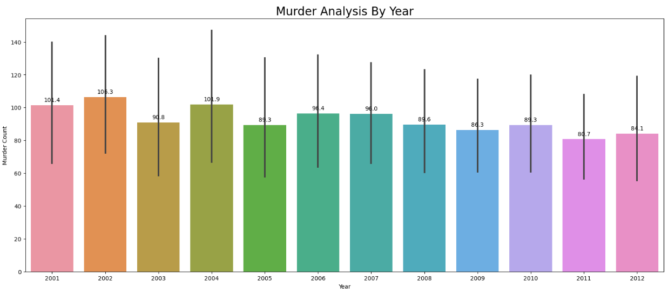

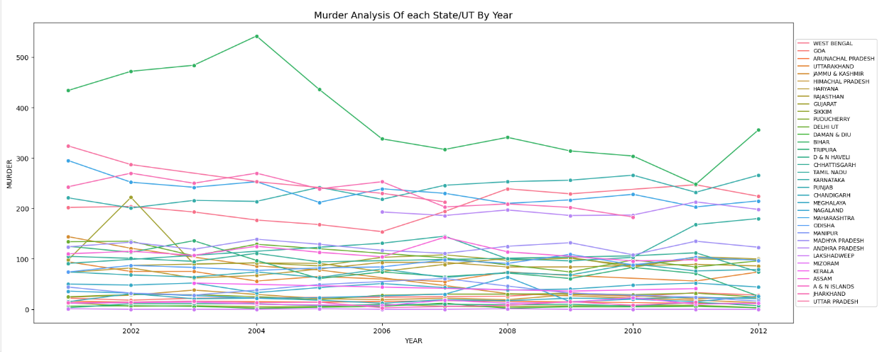

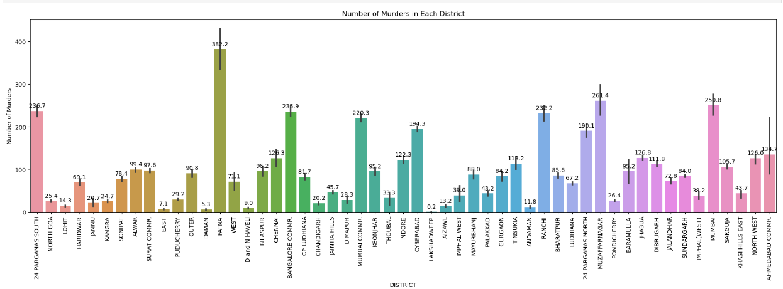 1. Murder Analysis by Year

* **Trend**: General decline in murder counts from 2001 to 2012.
* **Peaks**: Highest average in 2002 (106.3 murders), lowest in 2011 (80.7 murders).
* **Variability**: Error bars show significant year-to-year variability.

2: Murder Analysis by State/UT and Year

* **Variation**: Significant differences in murder counts across states/UTs.
* **Peak Period**: Highest counts around 2004-2005 for some states.
* **Decline**: General decrease in murder counts in top states/UTs post-2005.

3: Murder Analysis Murder in Each District

* **Peak:** Highest count in Patna District
* Lowest count in Lakshadweep

Insights from phase 4 analysis

### Insights from Sensitive and Peaceful Areas: Unsupervised Machine Learning Analysis

#### Sensitive Areas Insights

1. **Impact of Specific Crimes:**
   * **Dowry Deaths:** High in Uttar Pradesh, Bihar, West Bengal.
   * **Hurt/Grievous Hurt:** Significant in Uttar Pradesh, Maharashtra, Madhya Pradesh.
   * **Importation of Girls:** Notable in Assam, indicating trafficking issues.
   * **Insult to Modesty of Women:** High in Maharashtra, West Bengal, Uttar Pradesh.
   * **Kidnapping and Abduction:** Prominent in Uttar Pradesh, Maharashtra, West Bengal.
   * **Murder:** High in Uttar Pradesh, Bihar, Maharashtra.
   * **Rape:** Significant in Rajasthan, Uttar Pradesh, Madhya Pradesh.
   * **Assault on Women:** High in Uttar Pradesh, Maharashtra, West Bengal.
2. **Recommendations to Reduce Crime:**
   * **Enhanced Law Enforcement:** Increase police presence and establish task forces.
   * **Community Engagement:** Involve local leaders, conduct awareness programs.
   * **Strengthening Legal Framework:** Implement stricter laws and fast-track courts.
   * **Improving Socio-Economic Conditions:** Address poverty, unemployment, and provide skill development.
   * **Support for Victims:** Establish support centers, helplines, and online portals.
3. **Most Safe and Unsafe Districts:**
   * **Unsafe Districts:** Uttar Pradesh, Maharashtra, West Bengal.
4. **High Incidence of Crimes Against Women:**
   * Uttar Pradesh, Maharashtra, West Bengal.
5. **Trends in Property Crimes:**
   * **Auto Theft:** High in Delhi, Maharashtra, Uttar Pradesh.
   * **Burglary:** Significant in Uttar Pradesh, Maharashtra, West Bengal.
   * **Cheating and Criminal Breach of Trust:** High in Maharashtra, Uttar Pradesh, Delhi.
6. **Violent Crimes Variability:**
   * **Murder and Attempt to Murder:** High in Uttar Pradesh, Bihar, Maharashtra.
7. **Economic Crimes:**
   * High in Maharashtra, Delhi, Uttar Pradesh.
8. **Arson Problem Areas:**
   * Assam, West Bengal.
9. **Steps to Address High Crime Incidence:**
   * Focused Law Enforcement, Community Programs, Legislative Actions.
10. **Crimes with Highest Variability:**
    * Assault on Women, Kidnapping and Abduction, Rape.
11. **Organized Crimes Comparison:**
    * High in Uttar Pradesh and Maharashtra.

#### Observations from Investigation Case Trends (2001-2010)

1. **Number of Cases Pending Investigation from Previous Year:**
   * Fluctuates between 125 and 225, showing variability but no clear trend.
2. **Number of Cases Registered During the Year:**
   * Varies between 60 and 160 with noticeable peaks around 2002 and 2009, slight overall increase.
3. **Total Number of Cases for Investigation During the Year:**
   * Remains relatively stable with slight fluctuations, mostly within the 250 to 400 range, gradual increase.
4. **Number of Cases Pending Investigation at the End of the Year:**
   * Shows an upward trend, starting around 150 in 2001 and reaching about 225 by 2010, indicating accumulation of unresolved cases.
5. **Number of Cases Declared False or Non-Cognizable:**
   * Significant fluctuation with peaks around 2005-2006 and a rise towards the end of the period.
6. **Total Amount of Fine Imposed During the Year:**
   * Increasing trend with notable peaks around 2003, 2005, and 2009-2010, higher variability towards the end.

#### Peaceful Areas Insights

1. **Insult to Modesty of Women:**
   * Highest in Maharashtra.
2. **Cruelty by Husband or His Relatives:**
   * Highest in Uttar Pradesh.
3. **Importation of Girls from Foreign Countries:**
   * Low prevalence in many states.
4. **Death by Negligence:**
   * Highest in Maharashtra; negligible counts in some states.
5. **Other IPC Crimes:**
   * High in Maharashtra, Uttar Pradesh.
6. **Theft Cases:**
   * Highest in Maharashtra.
7. **Auto Theft:**
   * Most common in Delhi.
8. **Dowry Deaths:**
   * Highest in Uttar Pradesh.
9. **Assault on Women with Intent to Outrage Modesty:**
   * High in Maharashtra, Uttar Pradesh.
10. **Murder Cases:**
    * Highest in Uttar Pradesh.
11. **Kidnapping and Abduction of Women and Girls:**
    * Highest in Uttar Pradesh.
12. **Rape Cases:**
    * Most reported in Madhya Pradesh.
13. **Robbery Cases:**
    * Highest in Maharashtra.

**Suggestion**

Reducing crime in India requires a multifaceted approach that addresses underlying social, economic, and systemic issues. Here are several suggestions that can contribute to crime reduction:

1. **Strengthen Law Enforcement**:
   * **Improve Training**: Enhance the training programs for police officers, focusing on modern policing techniques, community engagement, and human rights.
   * **Increase Manpower and Resources**: Ensure police forces are adequately staffed and equipped with the necessary resources to perform their duties effectively.
2. **Enhance Community Policing**:
   * **Build Trust**: Foster a relationship of trust between the police and communities through regular engagement and outreach programs.
   * **Community Involvement**: Encourage community members to participate in crime prevention efforts by forming neighborhood watch groups and reporting suspicious activities.
3. **Utilize Technology**:
   * **Surveillance Systems**: Install and maintain CCTV cameras in public places to deter criminal activities and assist in investigations.
   * **Data Analytics**: Use data analytics and predictive policing to identify crime hotspots and allocate resources efficiently.
4. **Judicial Reforms**:
   * **Speedy Trials**: Implement measures to reduce the backlog of cases and ensure swift justice.
   * **Victim Support**: Strengthen support systems for victims of crime, including counseling, legal assistance, and rehabilitation.
5. **Address Socio-Economic Factors**:
   * **Education and Employment**: Invest in education and create job opportunities, especially for at-risk youth, to reduce the lure of criminal activities.
   * **Poverty Alleviation**: Implement programs to alleviate poverty and reduce economic disparities, which are often root causes of crime.
6. **Strengthen Legal Framework**:
   * **Update Laws**: Regularly update and revise laws to address emerging crime trends and ensure they are in line with current societal norms.
   * **Strict Enforcement**: Ensure strict enforcement of laws and impose appropriate penalties for criminal activities.
7. **Public Awareness and Education**:
   * **Awareness Campaigns**: Conduct public awareness campaigns on the consequences of crime and the importance of legal and ethical behavior.
   * **Education Programs**: Introduce crime prevention education in schools and communities to promote a culture of lawfulness.
8. **Rehabilitation Programs**:
   * **Prison Reforms**: Implement prison reforms focused on rehabilitation and reintegration of offenders into society.
   * **Support Systems**: Provide support systems for ex-offenders to prevent recidivism, including vocational training and employment opportunities.
9. **Address Corruption**:
   * **Anti-Corruption Measures**: Implement stringent anti-corruption measures to ensure accountability and transparency within law enforcement and judicial systems.
   * **Whistleblower Protection**: Strengthen protections for whistleblowers who report corrupt practices.
10. **Improve Urban Planning**:
    * **Safer Infrastructure**: Design and maintain urban infrastructure to enhance safety, such as proper street lighting, safe public transportation, and well-maintained public spaces.
    * **Inclusive Development**: Ensure that urban development plans include measures for crime prevention and community safety.

**Conclusion**

As nations worldwide strive for economic growth, addressing crime effectively becomes paramount. Visualizing crime data in India plays a vital role in this endeavour. Before the advent of sophisticated visualization tools, comprehending the intricacies of crime patterns and trends was a challenging task. However, with the advancements in data visualization, we are now better equipped to analyse and address crime efficiently.

The proposed approach leverages visualization techniques to provide a clear, comprehensive view of crime data, which can be utilized by law enforcement agencies and policymakers to make informed decisions. This model has been refined through extensive testing of various visualization methods to ensure it effectively highlights critical insights. Visualization is beneficial for identifying crime hotspots, trends, and anomalies, thereby aiding in resource allocation and policy formulation. The model is designed to be intuitive, allowing users to handle large datasets effortlessly while providing detailed, actionable insights.

This pitch aims to encourage law enforcement agencies, policymakers, and stakeholders to adopt and develop tailored visualization models suited to their specific needs. The ultimate goal is to enhance public safety, allocate resources efficiently, and formulate data-driven policies for crime reduction.